Task Report

SQL – the WHERE operator
There was a recent security incident in your organization. As a result, we gathered data to help in the investigation of the security incident.
    - find login attempts made after a particular date
    - find login attempts made on or after a particular date
    - find login attempts made between a date range
    - find login attempts made after a particular time
    - find login attempts made between two times
    - find login attempts using an event id tag

Task 1.
In this step, we find login attempts made after 2022-05-09

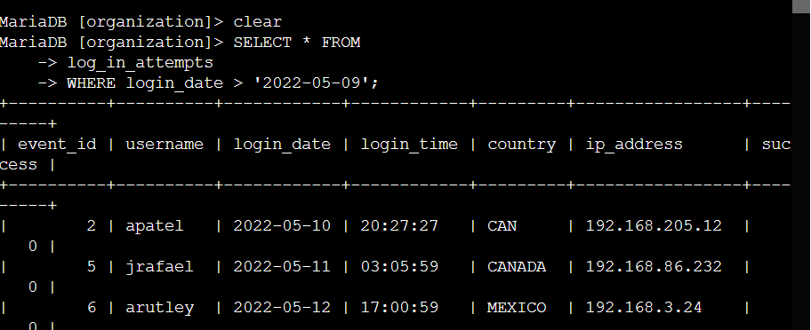

The following options can all be used along with the WHERE operator

= (equal)
- > (greater than)
- < (less than)
- <> (not equal to)
- >= (greater than or equal to)
- <= (less than or equal to)

Command Semantics
    - SELECT *
    - FROM log_in_attempts
WHERE login_date > '2022-05-09'; This command tells the computer to SELECT all (*) columns from the “log-in-attempts” table and only output the entries WHERE the login attempt was made after (>) 2022-05-09. The semi colon (;) indicates the end of the command.

Task 2.
This next step displays the difference between the previous operator (>) and the operator (>=).

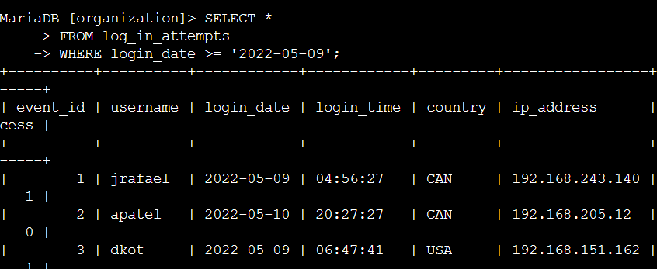

Command Semantics
    - SELECT *
FROM log_in_attempts
WHERE login_date >= '2022-05-09'; This command tells the computer to SELECT all (*) columns from the “log-in-attempts” table and only output the entries WHERE the login attempt was made on or after (>=) 2022-05-09.

Task 3.
In this task we retrieve login attempts made in a date range, as opposed to after a date.

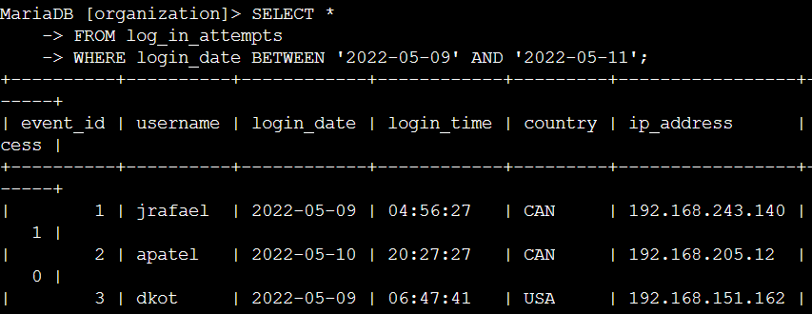

Command Semantics
    - SELECT *
FROM log_in_attempts
WHERE login_date BETWEEN '2022-05-09' AND '2022-05-11'; This command tells the computer to SELECT all (*) columns from the “log-in-attempts” table and only output the entries WHERE the login attempt was made BETWEEN 2022-05-09 AND 2022-0511.

Task 4.
In this step, we get more granular, like the dry rub gets once put on a hot juicy, nearly ready to serve hot wing. We need to sort out who was logging in outside of normal business hours.

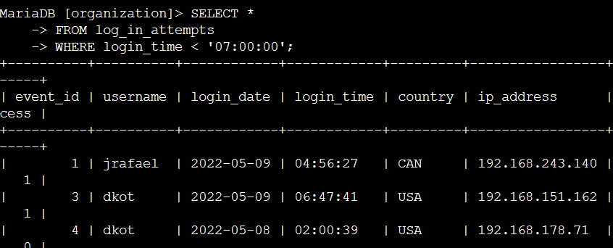

Command Semantics
    - SELECT *
FROM log_in_attempts
WHERE login_time < '07:00:00'; This command tells the computer to SELECT all (*) columns from the “log-in-attempts” table and only output the entries WHERE the login time was made before (<) 07:00:00

Task 5.
In this task, instead of looking for login attempts made before business hours we look for login attempts made just one hour before starting time.

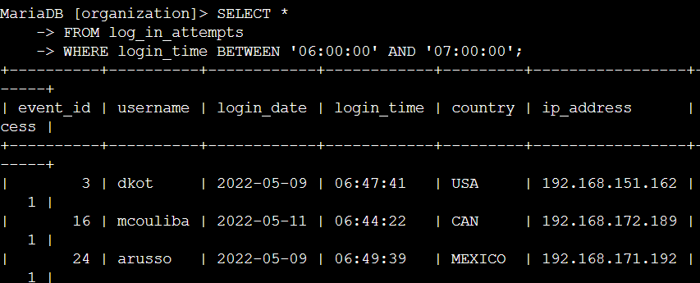

Command Semantics
    - SELECT *
FROM log_in_attempts
WHERE login_time BETWEEN '06:00:00' AND '07:00:00'; This command tells the computer to SELECT all (*) columns from the “log-in-attempts” table and only output the entries WHERE the login time was made Between 06:00:00 AND 07:00:00

Task 6.
In this step we investigate login attempts made with a specific event id.

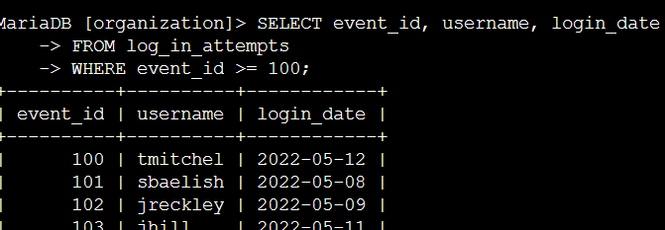

Command Semantics
    - SELECT event_id, username, login_date
FROM log_in_attempts
WHERE event_id >= 100; This command tells the computer to SELECT the “event_id”, “username”, and login_date” columns from the “log-in-attempts” table and only output the entries WHERE the event id is greater than (>) 100

Summary
In the cybersecurity field, Analysts are often tasked with sorting through login attempts to collect pertinent data, as the playbook would instruct, after an incident has occurred. This data can be used to prevent future attacks from occurring and strengthening their organization's security posture. SQL filtering is extremely useful in searching through so much data. Hot wings help as well. With ranch. And possibly on a silver platter served from a butler like they do for the scammers working at Axact. Hey?! Why do the criminals get all that special treatment? I swear, I did not get my degree from Axect, it's not possible – I dont have a degree, Im just useful naturally. Dont I just reek of usefulness? I hope my usefulness has rubbed off on you some. And now you reek of usefulness too. Alright, go take a shower now, kiddo, and have a great day. God bless the work of your hands.
- using the WHERE operator with it's various operators including (>, <, <=)
- using the BETWEEN operator (which is coupled with AND)

